**Covidien DrupalBuild Environment**

**Document**

**Revision History**

|  |  |  |  |
| --- | --- | --- | --- |
| **Author** | **Date** | **Version** | **Description** |
| ViSolve | August31, 2012 | 0.1 | **Initial revision** |
| ViSolve | September22, 2012 | 0.2 | **Updated with S5 deliverables** |

Table of Contents

Table of Contents 3

1 Purpose 4

2 Softwares/Tools to be present 4

3 Custom Drupal Installation 4

3.1 Uninstalling Drupal 4

3.2 Pre-requisites 5

3.3 Installation 7

3.4 Post Installation steps 11

Setting up User Management options: 11

# Purpose

This document provides the details on how to do custom installation of the Drupal using the modules developed by ViSolve.

# Softwares/Tools to be present

* Httpd – 2.2.3
* PHP – 5.3.5
* MySQL – 5.0.95

# Custom Drupal Installation

## Uninstalling Drupal

If you have Drupal installed in your machine, you can clean the existing setup following the steps given below. After making sure data are been backed up.

* Move to the location where drupal packages are present. In our case it is available in (/var/www/html).

# cd /var/www/html

* Remove the drupal folder that is currently available in this location.

# rm -rf drupal6 (OR)

# rm -rf drupal

* Next, remove the database and the corresponding user using the steps given below.

# /etc/init.d/mysqld start

# mysql

SQL>DROP DATABASE drupal6; (OR)

SQL>DROP DATABASE drupal;

* If the user doesn’t exist, please skip the following step.

SQL>DROP USER 'drupal6'@'localhost'; (OR)

SQL>DROP USER 'drupal'@'localhost';

## Pre-requisites

* Download covidien_web_drupal package from ‘Covidien Build Environment’ folder in dropbox. Check with Amir from Netspective for the dropbox access.
* Unzip the covidien_web_drupal.zip
* Create a directory with name ‘covidien’ inside the apache root directory to place the extracted files. Apache root directory can be either /var/www/ or /var/www/html. Here we have used /var/www/html as apache root directory.

#mkdir /var/www/html/covidien

* Copy the extracted files into covidien directory.

# cp -r covidien-web/* /var/www/html/covidien/

# cp covidien-web/.htaccess /var/www/html/covidien/

* Make sure .htaccess available in /var/www/html/covidien/ using below command

#ls –a

* Create settings file in the drupal directory

# cd /var/www/html/covidien

# cp sites/default/default.settings.php sites/default/settings.php

* Grant Permissions to settings.php and files folder

#chmod o+w sites/default/settings.php

#chmod o+w sites/default/files

#chmod o+w sites/all/libraries/tcpdf/cache

* Download Steps to download rpm from dropbox and install php-gd

# rpm -ivh php-gd-rpm

* Start the mysql daemon and login mysql

# /etc/init.d/mysqld start

# mysql -u root -p<password>

* Create database for drupal to get installed

SQL>CREATE DATABASE covidiendb DEFAULT CHARACTER SET utf8 DEFAULT COLLATE utf8_general_ci;

SQL>CREATE USER 'covidiendbuser'@'localhost' IDENTIFIED BY 'C0vidi3nDrp';

SQL>GRANT ALL PRIVILEGES ON covidiendb.* TO 'covidiendbuser'@'localhost' WITH GRANT OPTION;

*Note: You can replace “C0vidi3nDrp” with the password of you own.*

* Include maximum allowed packet size line in mysql configuration file my.cnf under [mysqld] section and restart mysql service. In common, my.cnf file will be located in etc directory.

# vim /etc/my.cnf

max_allowed_packet = 50M

default-storage-engine = innodb

Save the my.cnf file and restart the mysql server.

* Change the file upload size settings in php.ini file according to your requirement. In common, php.ini file will be located in etc directory. Here we have specified maximum file size to upload as 110M.

# vim /etc/php.ini

upload_max_filesize = 110M

post_max_size = 110M

* Change the memory limit settings in php.ini file to 128 MB.

memory_limit = 256M

Save the php.ini file and restart the apache server.

* Change the AllowOverride None to AllowOverride All in /etc/httpd/conf/httpd.conf to enable url rewrite for drupal and restart httpd.

#

# AllowOverride controls what directives may be placed in .htaccess files.

# It can be "All", "None", or any combination of the keywords:

# Options FileInfo AuthConfig Limit

#AllowOverride None

AllowOverride All

[AND]

# Each directory to which Apache has access can be configured with respect

# to which services and features are allowed and/or disabled in that

# directory (and its subdirectories).

#

# First, we configure the "default" to be a very restrictive set of

# features.

#

<Directory />

Options FollowSymLinks

AllowOverride All

</Directory>

## Installation

* Access the drupal directory from web browser. Specify the url like

http://<IPAddress>/covidien

* On successful completion of pre-requisites steps in 3.2, database configuration screen will get displayed when accessed from web browser. Enter the database name, username and password created in previous section. Click on ‘**Save and continue’**.

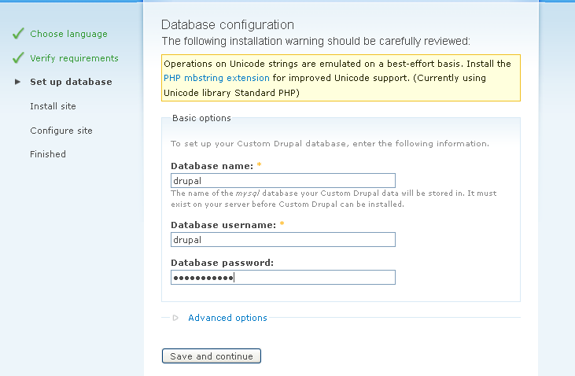

* Custom installation of drupal will get displayed.

NOTE: In case you face any issues during this install process, increase the **memory_limit** using the steps mentioned in section 3.2.

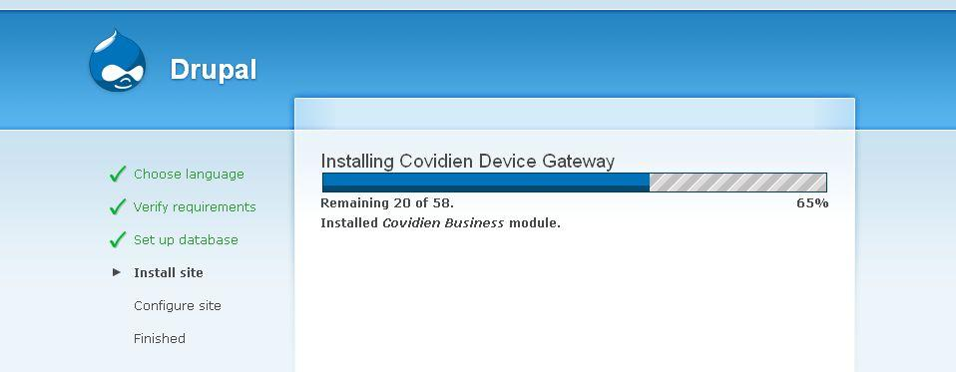

* Enter the necessary details like site name, email address and other credentials on **Configure site** page. Then click ‘**Save and continue’**.

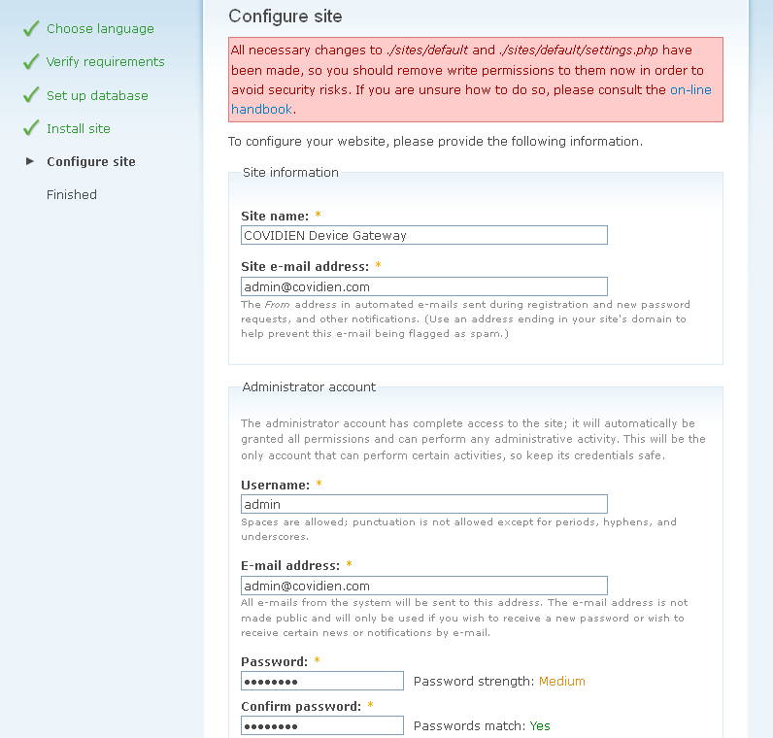

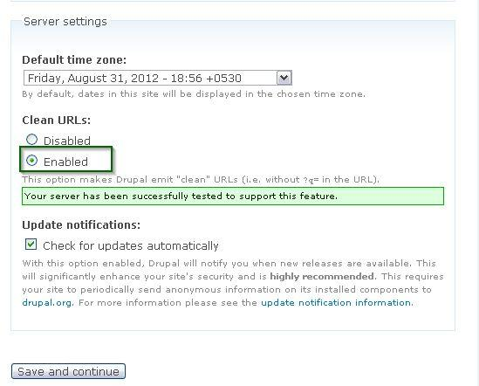

**Note: Please use secured username and passwords.**

* Once Custom Drupal Installation is completed, click on “**Your new site**”.

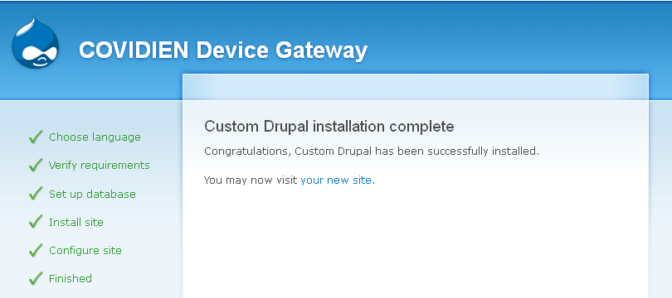

* On successful completion of installation, the following screen will be displayed.
* Login with the username password provided above and create a new admin user to view the user settings link(the drupal default user created during the time of installation will not have any user profilesassociated so user settings link will not work).

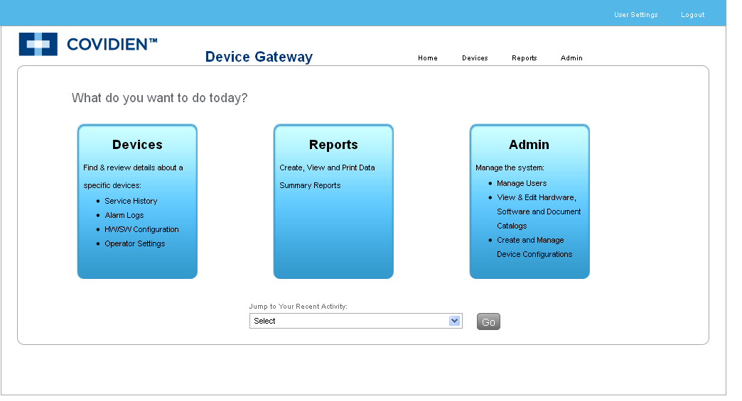

## Post Installation steps

### Setting up User Management options:

* Go to{DRUPAL_SITE}/admin/content/node-type/person in the browser and check Use this content type as a content profile for users under content profile. Click **‘Save Content Type’.**

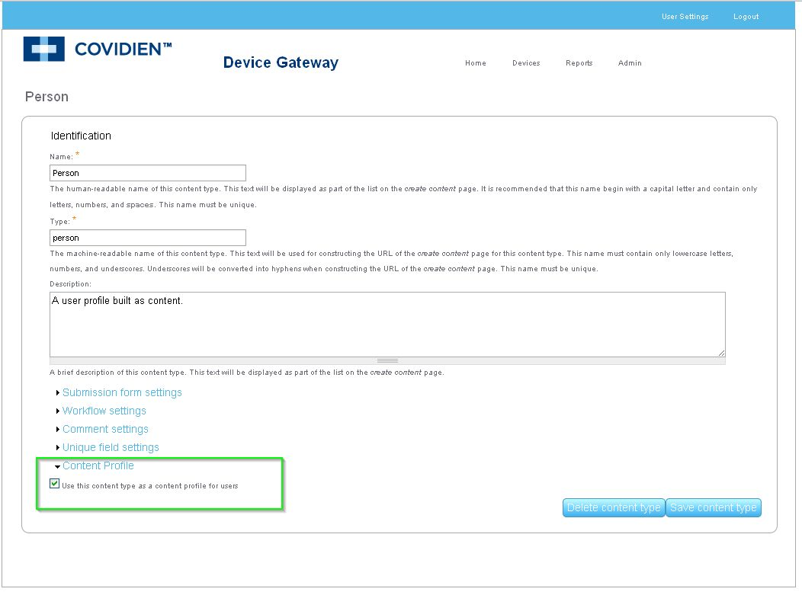

* Go to{DRUPAL_SITE}/admin/content/node-type/user-settings in the browser and check Use this content type as a content profile for users under content profile. Click **‘Save Content Type’.**

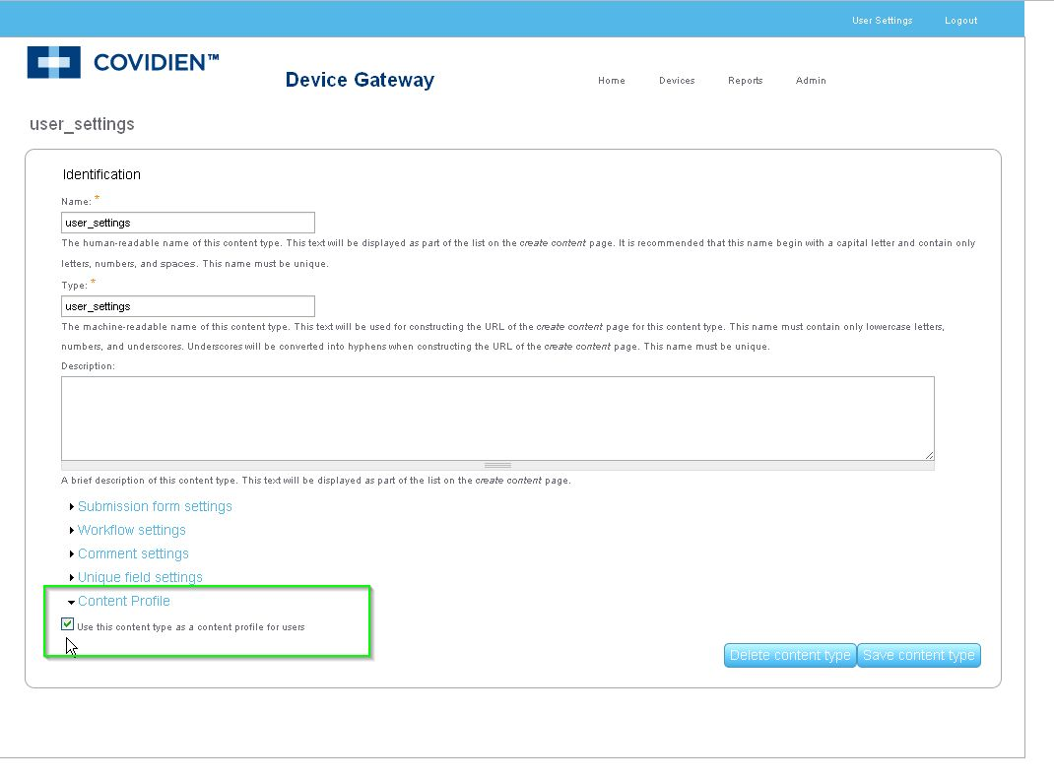

* Go to{DRUPAL_SITE}/admin/content/node-type/user-settings/profile in the browser and check Use on Registration, Use on administrative user creation form and Title. Click **‘Submit’.**

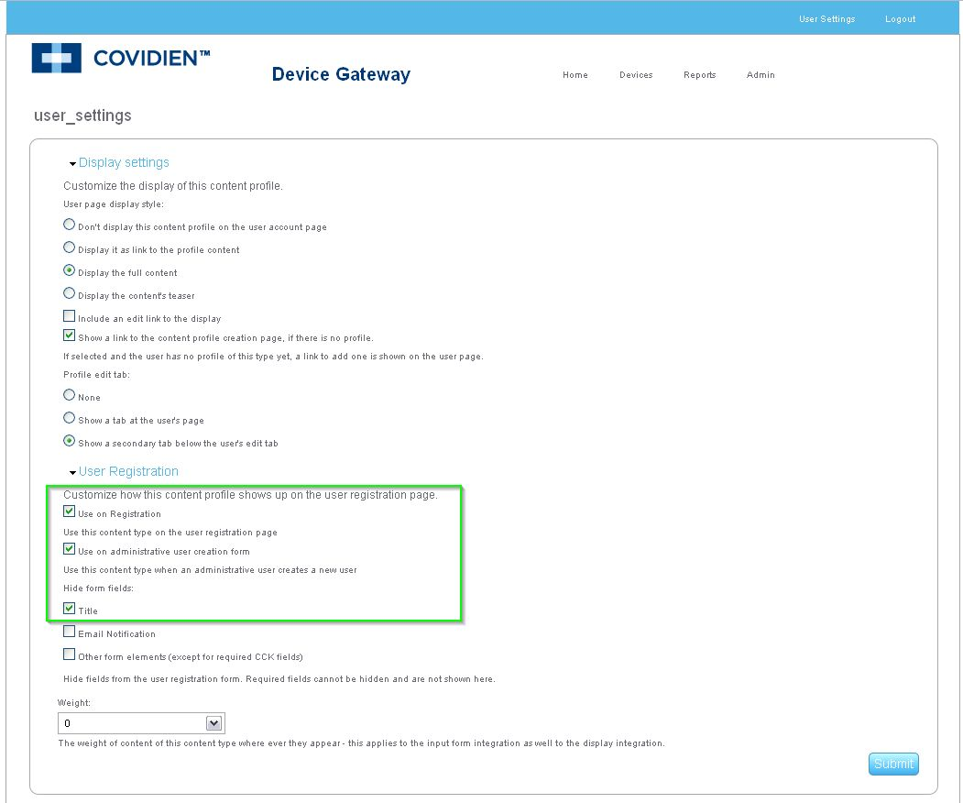

* Enter{DRUPAL_SITE}/admin/content/node-type/person/profile in the browser and check Use on Registration, Use on administrative user creation form and Title. Click **‘Submit’.**

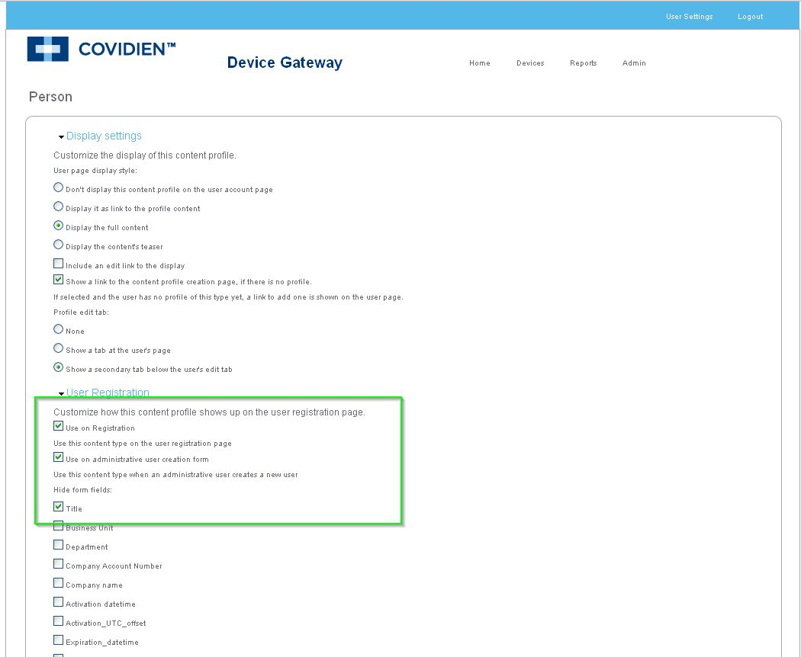

* Enter{DRUPAL_SITE}/admin/settings/login_security in the browser and enter ‘3’ in Maximum number of login failures before blocking a user field and leave the field ‘Message when user is blocked by uid:’ as empty. Click **‘Save Configuration’**.

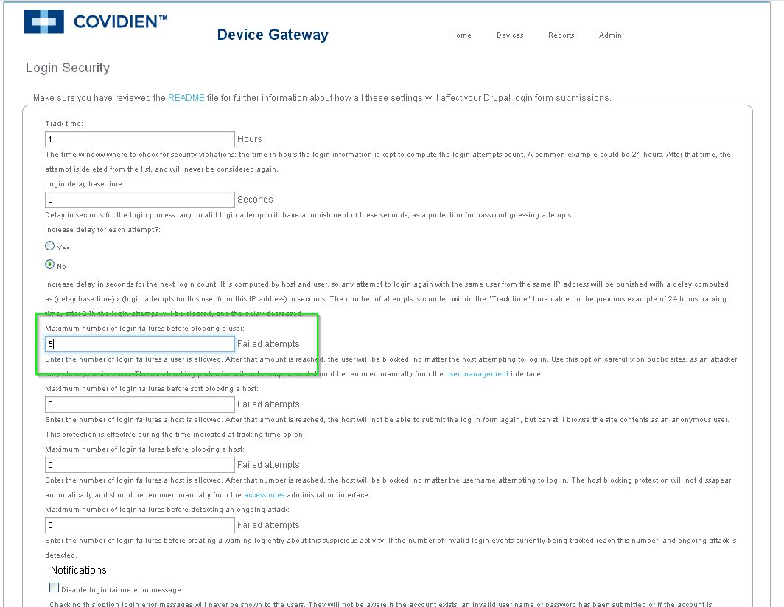

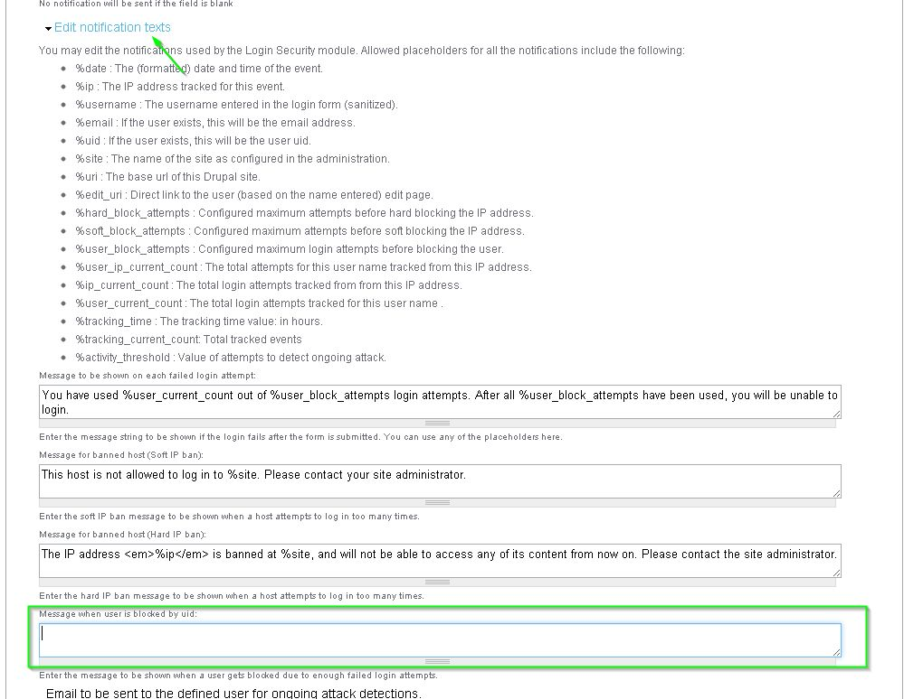

* Go to {DRUPAL_SITE}/admin/user/permissions and click on **’Save Permissions’**to refresh.

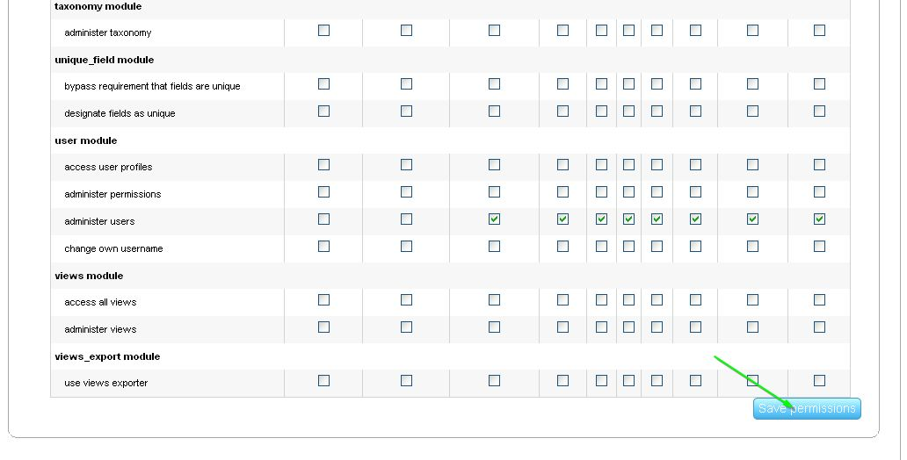

* Go to {DRUPAL_SITE}/admin/settings/autologout , check “Enable module“ , enter 1800 in “Timeout value in seconds: “ and click on **’Save configuration’** to refresh.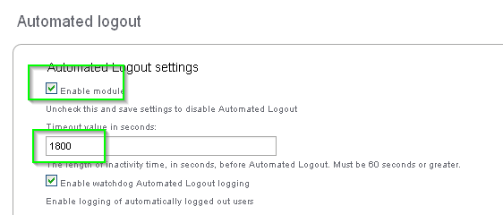

**Setting up Repository path, Password expiration and permissions to upload files:**

* Include the following lines at the end of settings.php file in (/var/www/html/covidien/sites/default) [created in 3.2]

$drupal_abs_path = '/var/www/html/covidien/'; <location where drupal is installed in current machine>

$drupal_repourl = '<IP address of Software/Document repository>';

$drupal_swrepo = "software/";

$drupal_docrepo = "document/";

$drupal_password_expiration_day = "90"; <Password expiration days>

$expire_notice = "5"; <Days before to start noticing user about expiration>

* Permissions to be set

# chown -R apache:apache /var/www/html/covidien/sites/default/files/  
  
#chmod -R o+w /var/www/html/covidien/sites/default/files/

* Before Configuring cron, Please make sure sufficient access available for files and repository is accessible by that machine using

https://<drupal_repourl>/upload.php

* Setting up Cron Job to populate sha1 integrity and to compress the uploaded files to be sent to repository. This cron job will run every five minutes.

#crontab -e

Include the following line in crontab and save the file.

*/5 * * * * wget -O - -q -t 1 http://{DRUPAL_SITE}/cron.php (check http/https before using in cron)

**To increase the size of database logging.**

Note: Use ‘<http://url>/admin/settings/logging/dblog’ to increase the number of entries in the database log.